***Southwind of Lake Elmo***

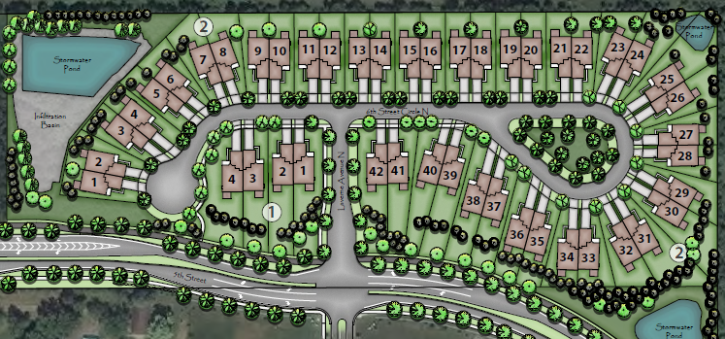

**WO**

**WO**

**WO**

**WO**

**WO**

**LO**

**WO**

**WO**

**WO**

**WO**

**LO**

**LO**

**LO**

**LO**

**SL**

**SL**

**WO**

**LO**

**LO**

**WO**

**WO**

**WO**

**WO**

**WO**

**WO**

**KEY:** Sold 2021 Model Available in Progress (90 – Day Close) Unmarked- Lot available